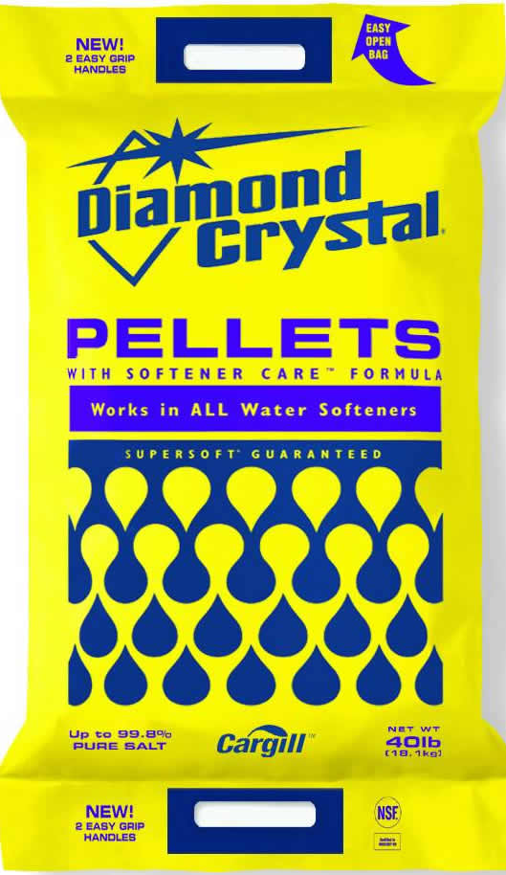
Softener Salt: Pellets
- Works in all water softeners
- Pellets
#48
- 40 Lbs.
$4.99
X44822

